Entity Name

20XX Leadership Accountability Report Submission Date

Submission Date
BLUE text is determined by the reporting entity. BLACK text is determined by the web portal.

Director of Finance Name, Title

Dear Director of Finance Name,
In accordance with the State Leadership Accountability Act, the <Entity Name> submits this report on the review of our risk management and internal control systems for the annual period ending June 30, 20XX.
Should you have any questions please contact Name, Title, at Phone Number, E-mail Address.

GOVERNANCE
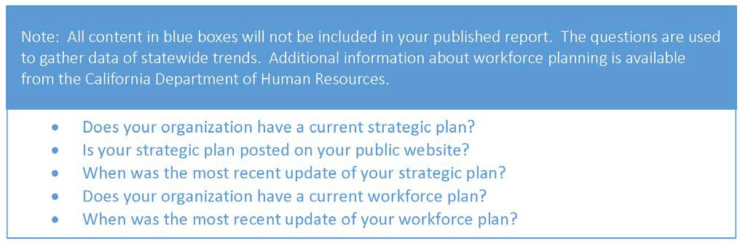

Mission and Strategic Plan
Describe the mission and strategic goals

This section of the report must include: (web portal entry limited to 25,000 characters)
- Entity mission, strategic goals, and objectives
- All entities under your reporting responsibility

Control Environment
Describe how management establishes an effective control environment
This section of the report must include: (web portal entry limited to 25,000 characters)
- Management’s establishment and demonstration of integrity and ethical values (core values, codes of conduct, ability to report ethical concerns, etc.)
- Oversight by a board, outside entity, or the top executive
- Organizational structure to ensure appropriate levels of responsibility and authority
- Maintaining documentation of the control system

- Establishing and maintaining a competent workforce
- Enforcement of accountability (include consideration of unreasonable/excessive pressures)
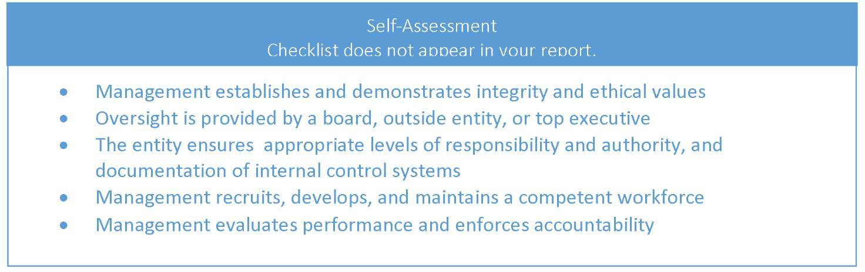

Information and Communication
Describe the structure and types of internal and external communication

This section of the report must include: (web portal entry limited to 25,000 characters)
- Process to collect and communicate relevant and reliable information needed for operational, programmatic, and financial decision making
- Channels for communicating:
  - Up, down, and across the entity among staff and management
  - Across organizational lines
  - With external stakeholders
- Process for employees to report inefficiencies and inappropriate actions to management and other decision makers
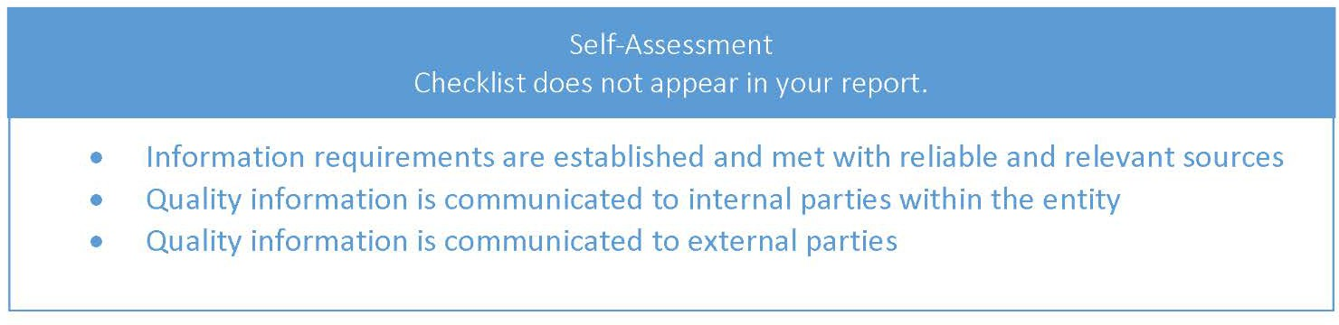

MONITORING
The information included here discusses the entity-wide, continuous process to ensure risk management and internal control systems are working as intended. The role of the executive monitoring sponsor includes facilitating and verifying that the <Department Name> monitoring practices are implemented and functioning. The responsibilities as the executive monitoring sponsor(s) have been given to: Selected Name, Title, and Selected Name, Title (as applicable).
Describe the process(es) used entity-wide to ensure the effectiveness of the risk management and internal control systems and how management responds to vulnerabilities as they are identified.

This section of the report must include: (web portal entry limited to 25,000 characters)

- Confirming effectiveness of internal control systems using:
  - Routine activities to identify potential problems (e.g., tracking key performance indicators, meetings, and reconciliations)
  - Periodic detailed reviews, which are best performed by:
    - Knowledgeable staff not directly involved with day-to-day operation of the control system under review
    - Internal or external reviewers
- Comparison of results to expectations and determination if changes are needed
- Process to assign ownership for addressing vulnerabilities identified through monitoring
- Monitoring of progress to reduce the identified vulnerabilities
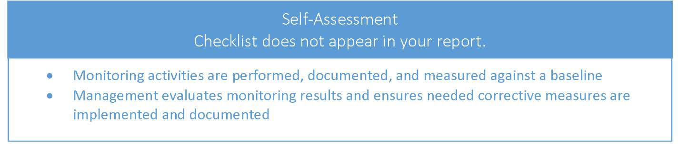

RISK ASSESSMENT PROCESS
Portal will now include standardized checkboxes for the three components of the risk assessment process. However, the option to write a supplemental narrative will be available as well.

The following personnel were involved in the Entity risk assessment process: Select all that apply from the following options: Executive Management, Middle Management, Frontline Management, and Staff

The following methods were used to identify risks: Select all that apply from the following options: Brainstorming Sessions, Employee Engagement Surveys, Ongoing Monitoring Activities, Audit/Review Results, Other/Prior Risk Assessments, External Stakeholders, Questionnaires, Consideration of Potential Fraud, Performance Metrics, and Other
The following criteria were used to rank risks: Select all that apply from the following options: Likelihood of Occurrence, Potential to Impact Mission/Goals/Objectives, Timing of Potential Event, Potential Impact of Remediation Efforts, Tolerance Level for the Type of Risk, and Other

Optional narrative: (web portal entry limited to 4,500 characters)
You may include a narrative of your risk assessment process to supplement your answers from above
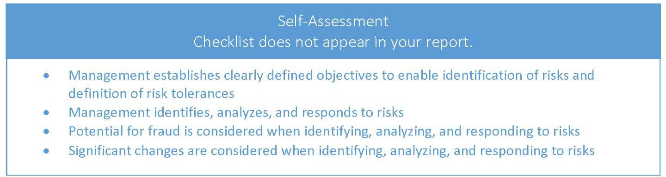

RISKS AND CONTROLS

Risk Title (repeats for each risk listed in the portal)
Provide a title for this risk, this title will appear in the printed report (web portal entry limited to 2,500 characters)

Describe your entity’s risk and provide information necessary to understand the risk. Risk statements include three elements:

The description must include
- An event causing concern
- Root cause(s) for the event
- Impact(s) to goal(s)/objective(s) if the event occurs

Control Title (repeats for each control listed in the portal)
Provide a title for this control, this title will appear in the printed report (web portal entry limited to 1,250 characters)

Describe each activity being used to reduce the risk. This section of the report must include:
- Description of the control activity
- Explanation of how this activity reduces the risk
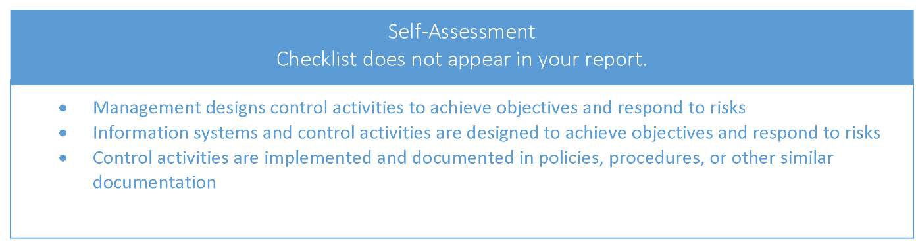

CONCLUSION
The Entity strives to reduce the risks inherent in our work and accepts the responsibility to continuously improve by addressing newly recognized risks and revising mitigation strategies as appropriate. I certify our risk management and internal control systems are adequate to identify and address current and potential risks facing the organization.

Additional Comments—Optional

Entity Head Name, Title

CC:
California State Library

