Adding COVID-19 Custom Attributes to a Project in FI$Cal

Version: 4.0 Updated: 09/23/2021

Purpose

This Supplemental Job Aid provides instructions on establishing COVID-19 related Projects to be used in tracking transactions.
Table of Contents

Purpose 1
Target Audience 1
Key Points 2
Project Attribute Values with Transaction Examples 3
Create Project to Track COVID-19 Transactions 5
Reclass Transaction to Include the COVID-19 Project 14
Purchase Orders (PO) 14
Accounts Payable (AP) 15
Accounts Receivable (AR), Billing (BI), AR Payments 16
Labor Distribution (LD) 16
General Ledger (GL) Journal 17
Appendix 18
Key Words 18
Definitions 18
Reference Materials 18
Revision Table 19
Contacts 19

Target Audience

Departments with Summary Roles Assigned:

PC Processor

Departments with End-User Roles Assigned:

Department Project Processor

Key Points

To facilitate statewide tracking and reporting of COVID-19 related activities, the Department of Finance (Finance) requires all COVID-19 related transactions (e.g., purchase orders, vouchers, receipts) in FI$Cal to be tagged as COVID-19. In Project Costing (PC), FI$Cal and Finance have established a COVID-19 Custom Project Attribute and four Attribute Values – (1) COVID-19 Response, (2) COVID-19 Testing and Contact Tracing, (3) COVID-19 Stimulus Programs – for tracking COVID-19 transactions funding by federal stimulus funds (fund 0890 or fund 8505), and (4) State Fiscal Recovery Fund (8506) – for tracking state projects that receive an appropriation from this fund. COVID-19 Attribute Values will be chosen from the drop-down function to allow for uniformity across all Business Units (BUs) to aid in reporting. Updates for the new Fund 8506 (Coronavirus Fiscal Recovery Fund of 2021) are in blue for departments with 2021 appropriations from this fund. Budget Letter 21-03 provides additional details related to the first three attributes and a future Budget Letter will provide additional information about statewide COVID-19 cost tracking and reporting, including Fund 8506.

Note:
- You must add the COVID-19 Custom Project Attribute and Attribute Values to a Project ID for the Project ID to be tagged as COVID-19.
- You must add a Project ID (tied to COVID-19 Custom Project Attribute and Attribute Values) and Activity ID to a transaction line for the transaction to be tagged as COVID-19.
- COVID-19 Custom Project Attribute and Attribute Values will be associated at the Project header level – this means all transaction lines referencing this Project ID and Activity ID will be tagged as COVID-19.
- Department will continue to create its own Project ID to maintain its internal structure; no smart coding will be required.
- Department will continue to create its own Activity ID(s) to maintain its internal structure; no smart coding will be required. (A minimum of one Activity is required for the Project.)
- This Job Aid does not show steps related to Grant Awards in the Grants Module – Department will continue to create its Grants using its internal process.
- This Job Aid does not show steps related to Customer Contracts for billing automation – Department will continue to create its Customer Contracts using its internal process.
- For departments following the COVID-19 “Emergency Attributes” memo from the California Office of Emergency Services (Cal OES) – The COVID-19 Custom Project Attributes are in addition to the COVID-19 Emergency Attributes you were instructed to add to projects via Job Aid: FISCal.339 – Adding Statewide Emergency Attributes to Projects and Incident Numbering starting with step 8 on page 14. Both the Emergency Attributes and the Custom Project Attributes must be added to COVID-19 projects.

Cal OES has assigned the Statewide Incident #2020-03-ID00029 for the evolving response activities related to the Novel Corona Virus (COVID-19).
  - Statewide Incident Number: 2020-03-ID00029
  - Statewide Incident Name: COVID-19
  - Emergency Type: Pandemic
  - Incident Location: 49 counties

Project Attribute Values with Transaction Examples

Response
Various activities that support the emergency response undertaken by departments in direct response to the pandemic. Activities include, but are not limited to:
- Additional cleaning and sanitation protocols.
- Purchases that support the ability of staff to to telework, or support the implementation of social distancing protocols and public health guidance, such as the purchase of personal protective equipment or partitions and barriers.
- Any activity mission tasked to a department by Cal OES. These are also tracked per guidelines from Cal OES and reported to Finance pursuant to Budget Letter (BL) 20-10, BL 20-32, and BL 21-03.
- Redeployment or redirection of staff from regular assignments to COVID-19 response (such as redirection of staff to the State Operations Center or to help support increases in unemployment insurance claims). This would not include staff that are redirected to testing and contact tracing activities identified in the “Testing and Contact Tracing” section below.
- In most cases, departments have absorbed these costs within existing resources but the state may have an opportunity to submit requests for reimbursement either through the Cal OES/FEMA process, or to allocate costs incurred to the federal Coronavirus Relief Fund. Departments should track and report these costs but may not receive direct reimbursement.

Testing and Contact Tracing
Activities that support statewide testing and contact tracing, as outlined by the California Department of Public Health and the California Health and Human Services Agency. This would include staff that are reassigned to help support this effort.

Stimulus Programs
Many existing programs have been used to rapidly allocate federal stimulus funds. The COVID-19 funds must be tracked separately from the base program funds, even if the Catalog of Federal Domestic Assistance (CFDA) is the same for both. In addition to tracking them separately, it is important to note that COVID-19 allocations may also have unique requirements relative to allowable uses (including flexibility), matching, reporting, or period of availability, which must be carefully tracked or monitored. The majority of the funding being allocated to or through the state, as reported pursuant to the federal tracking drill, will fall into this category.

State Fiscal Recovery Fund
As part of the state’s continued response to COVID-19 and long-term economic recovery, various recovery and assistance programs have been authorized using funds received from the federal government from the Coronavirus State Fiscal Recovery Fund, authorized by the American Rescue Plan Act of 2021. Only departments that receive an appropriation from the new federal fund—Coronavirus Fiscal Recovery Fund of 2021 (fund code 8506) will use this new attribute value. A combo edit was established in the system to require a Project for this fund; however, this federal fund will not be added to the Federal Trust Fund (FTF) Tree.

Create Project to Track COVID-19 Transactions

Steps | Description
1 | Establish a new project for tracking transactions. Navigate to the General Information page to add a new project:  - Navigation: Main Menu Project Costing Project Definitions General Information  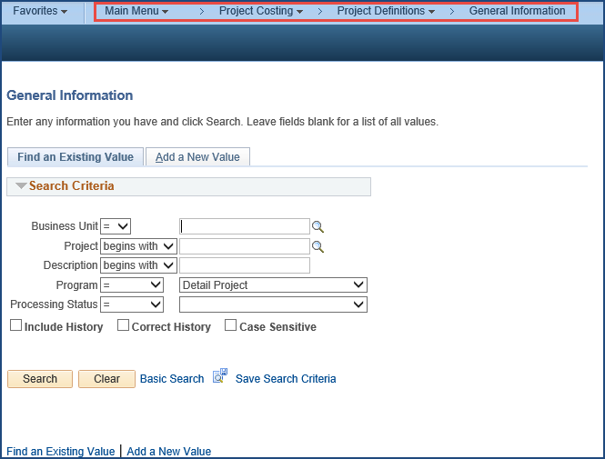
2 | Click the Add a New Value tab  A new Project is created by clicking the Add a New Value tab and entering the following:  - Business Unit  - Project: System will generate the next available Project number if using the “NEXT” functionality. If not using the “NEXT” functionality, enter the Project number manually.  Then click the Add button.  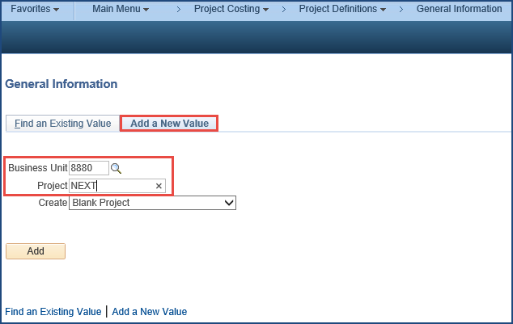
3 | On the General Information tab, enter or select values for the following:  - Description: <Enter project description> This is a 30 character field  - Integration: <Department Business Unit>  - Project Type: <Select a Value> Use the appropriate Project Type based on the project being created (use FEDRL for Fund 8506)  - Start Date: <User Defined> Establish start date based on when activity was authorized  - End Date: <User Defined> Include the planned end date for this Project. Ideally this date will be consistent with dates reported to the Finance and the U.S. Treasury for each entity that receives funds from the state.  - Description: Enter detailed description (optional) under Project Schedule section  Click Save.  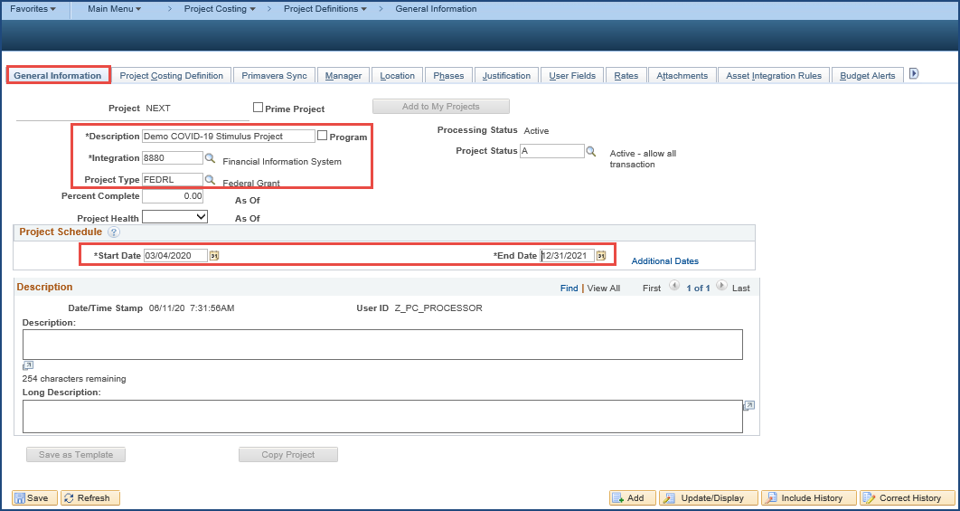
4 | (Federal Projects Only – Project Type FEDRL): Federal Projects will be sent to the User Fields tab, click OK to message. Enter CFDA Number, P/N and C then click on Save (system will generate Project ID, if NEXT was used).  Note: If you received a new CFDA grant, please ensure you have the Sequential Number and Character number from SCO – the System will not allow blanks in these fields.  Note for Fund 8506: AUD10a is not needed; CFDA = 21.027, P/N = 01, and C = M. Additionally, this Federal project is not linked to the FTF tree.  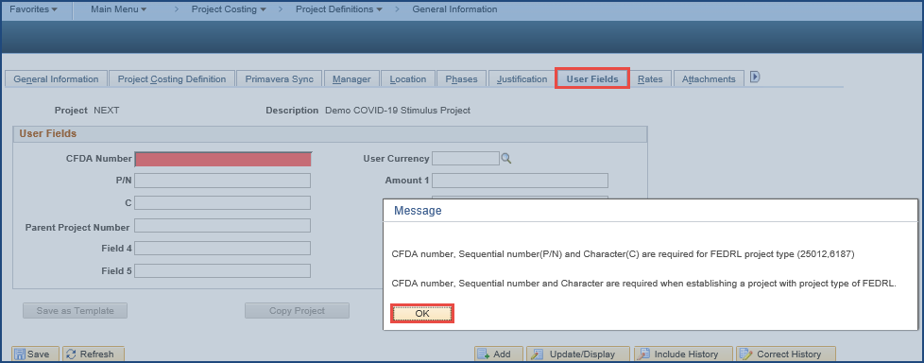  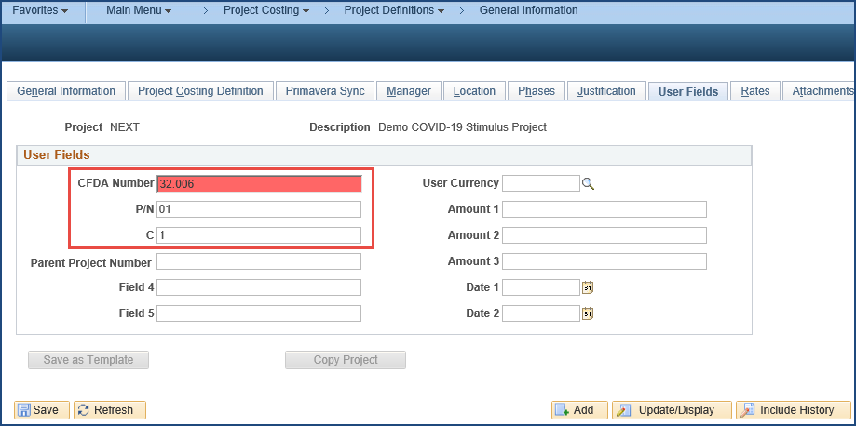
5 | Create Activity ID(s) for Project. Click on the “Project Activities” hyperlink at the bottom of the page:  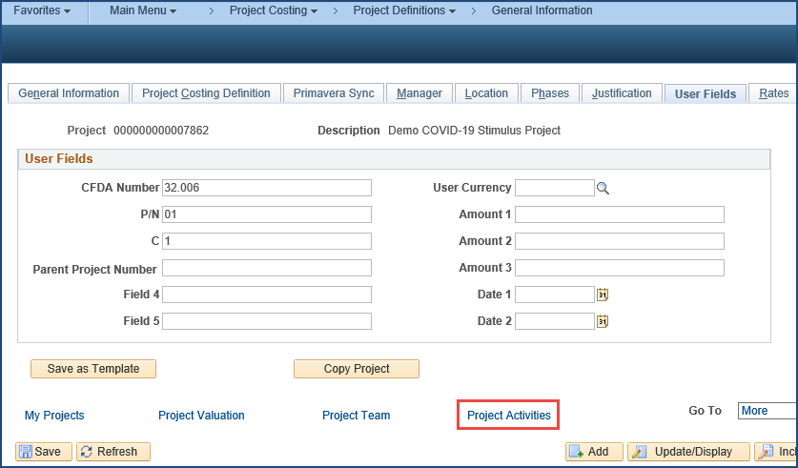
6 | On the Project Activities page under the Schedule tab, enter Activity Name then click the Save button. Can also replace the “NEXT” in Activity field if a certain value is required to maintain an internal structure and detail tracking. Then click the Activity Definition icon (on righthand side next to the “Percent Completed” field) to activate the status of the project activity. This will open General Information page.  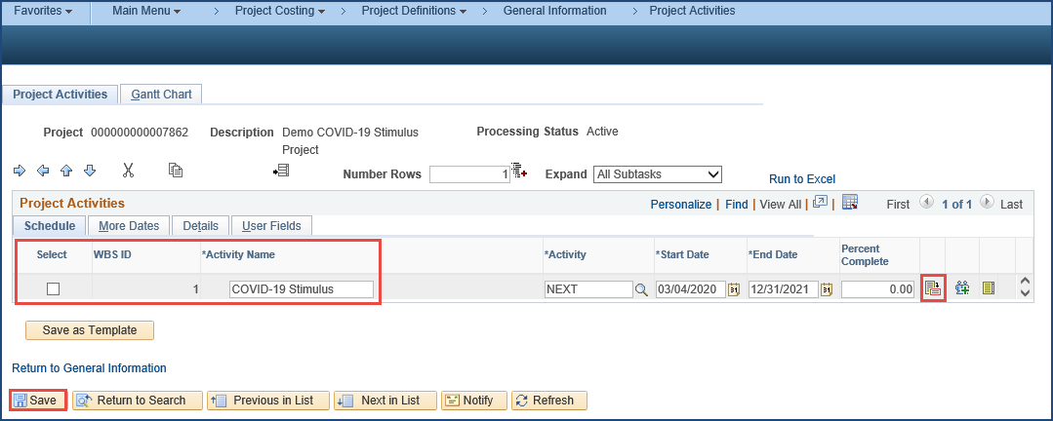
7 | On the bottom of the General Information page, click the Activity Status hyperlink.  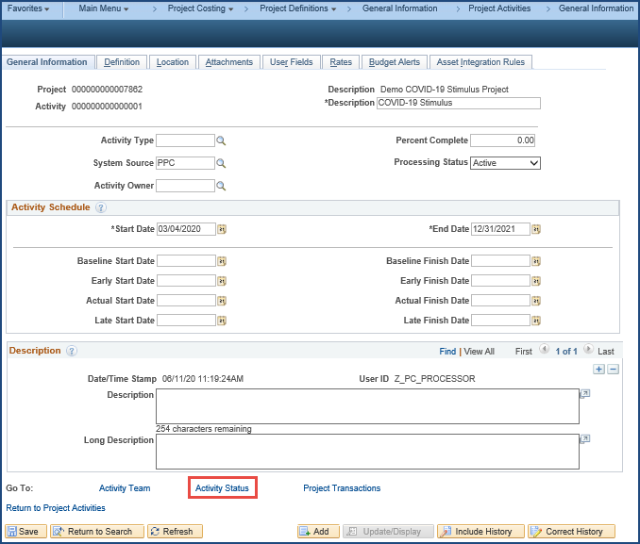
8 | On the Status page, set Effective Date to be the same as the Project start date, select “A” (for Active) from the Status prompt, then click the Save button.  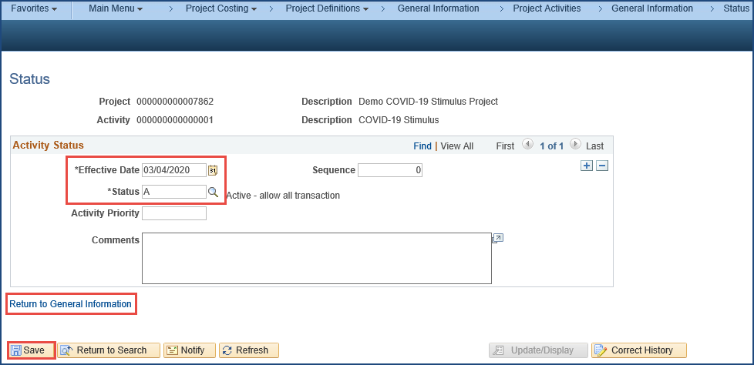  Then click on the “Return to General Information” hyperlink to go back to General Information page as shown on Step 7.  Then click on the “Return to Project Activities” hyperlink to go back to Project Activities page as shown on Step 6.  Then click on the “Return to General Information” hyperlink.
9 | Navigate to the Project Attributes tab (by clicking on the arrow and scrolling to the right).  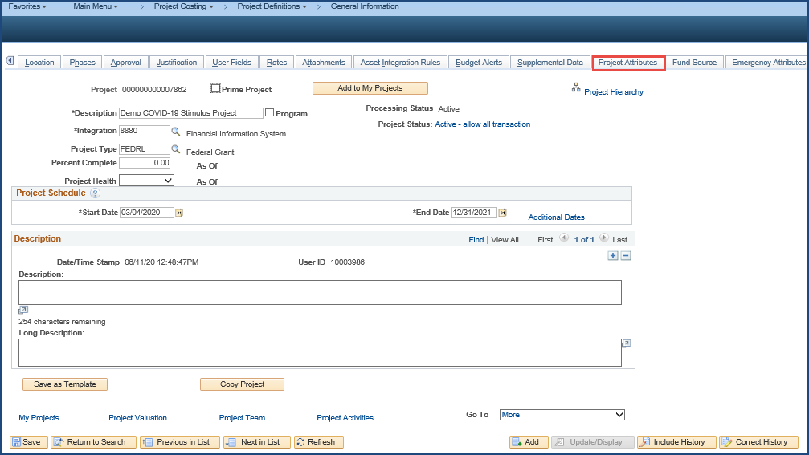
10 | Click the Project Attributes tab and in the Custom Attributes section, enter the following values:  - Attribute Name: click Lookup, select “COVID-19”  - Value Drop Down: <select from dropdown>  - “Response” – for tracking expenditures directly related to COVID-19 response  - “Testing and Contact Tracing” – for tracking expenditures directly related to COVID-19 testing and contact tracing  - “Stimulus Programs” – for tracking expenditures directly related to COVID-19 stimulus programs  - “State Fiscal Recovery Fund 8506” – for tracking state projects that receive an appropriation from this fund only  Then click Save.  Note: A project should only have one project attribute with “COVID-19” and a single attribute value. Also, the project should only be used to track COVID-19 costs of the specified type (“Response”, “Testing and Contact Tracing”, “Stimulus Programs”, or “State Fiscal Recovery Fund”). If the BU has COVID-19 activities of multiple types, multiple COVID-19 projects should be created. Any non-COVID-19 expenditures should be tracked with a different project.  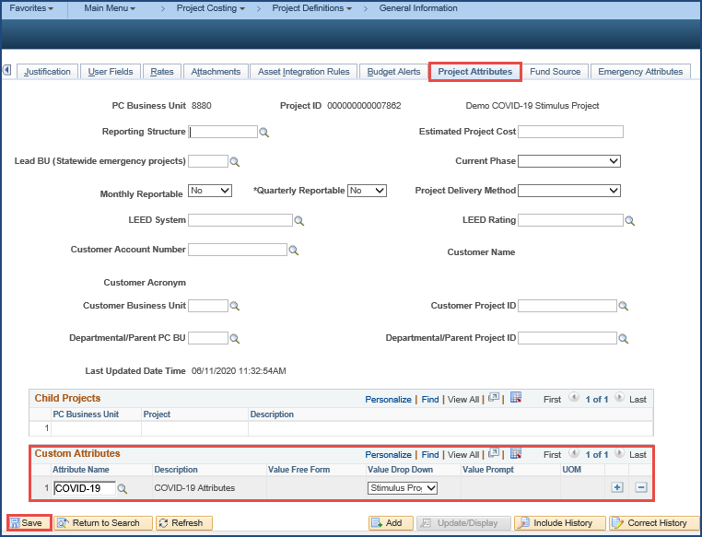
11 | (Federal Projects Only – Project Type FEDRL) Create a Configuration Modification Request (CMR) via ServiceNow – instructions located here: Create a Configuration Modification Request – to add the new Project(s) to the FTF Tree under the appropriate CFDA number. Fund 8506 will use FEDRL Project Type but will not be added to the FTF tree (no CMR).  You have now successfully created the Project and Activity related to COVID-19 to be used on transactions in other modules (like Purchase Orders, Vouchers, Accounts Receivable, General Ledger, etc.). All transactions related to COVID-19 must be associated with a COVID-19 Project to facilitate statewide tracking and reporting.
12 | Enter Project ID and Activity ID on all transactions related to COVID-19.  Note: You must add a Project ID (tied to COVID-19 Custom Project Attribute and Attribute Values) and Activity ID to a transaction line for the transaction to be tagged as COVID-19. COVID-19 Custom Project Attribute and Attribute Values will be associated at the Project header level – this means all transaction lines referencing this Project ID and Activity ID will be tagged as COVID-19.  PO Distribution Line Entry  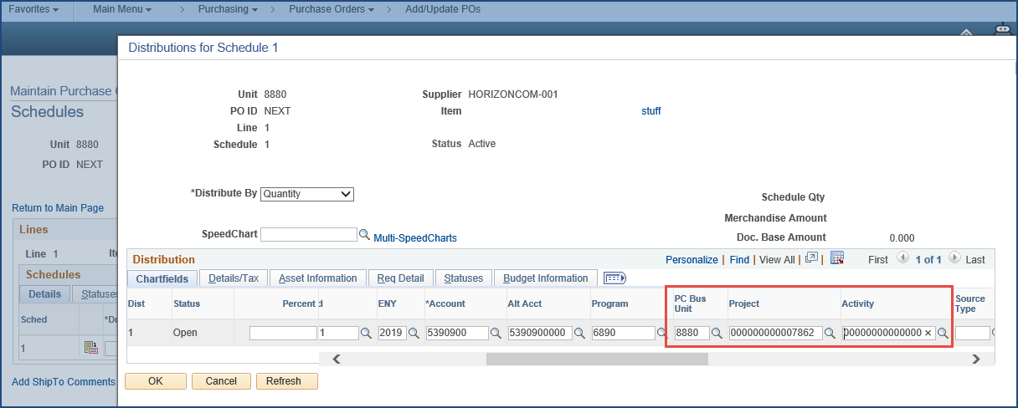  Voucher Distribution Line Entry  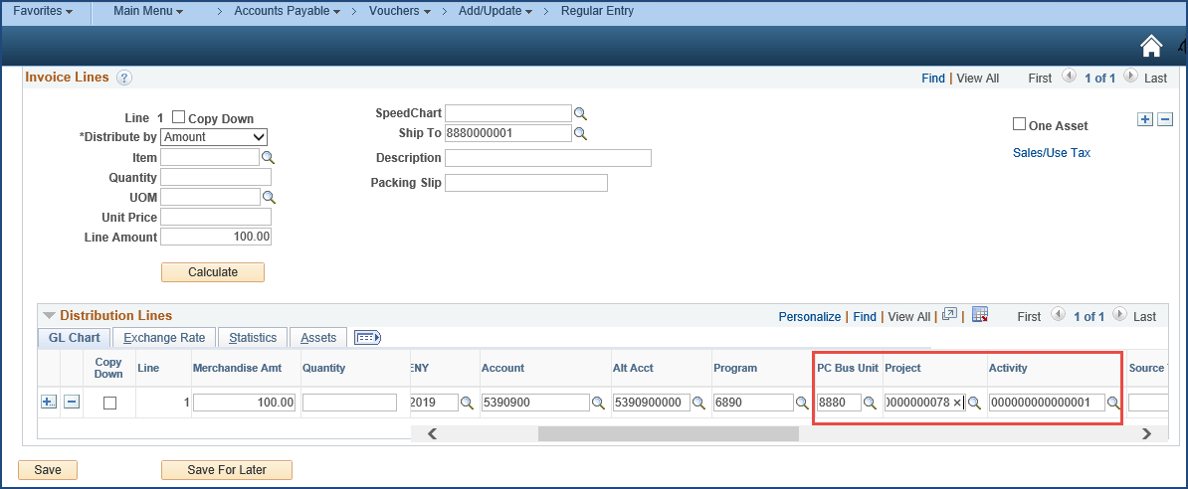

Reclass Transaction to Include the COVID-19 Project

Departments were required to create COVID-19 Projects to capture three main categories of transactions for COVID-19 related activities: 1) Response, 2) Testing and Contact Tracing, and 3) Stimulus Programs. Confirm that the transaction includes the COVID-19 Project to accurately track and report COVID-19 activity by the department and State.

Departments that created Projects at the time of the transaction can add the COVID-19 Project Attribute and Attribute Value to their existing project(s). The Project Attribute will be picked up for transactions created with that Project ID. If the Project Attribute Value is correct for all transactions, no reclass is necessary.

Departments that did not create a COVID-19 Project at the time of the transaction or have transactions that need to move to a different COVID-19 Attribute value, must reclass the transactions. The process to reclass a transaction should take place within the submodules. If this is not feasible, departments may create a high-level General Ledger Journal. See the module selections below for information to re-class the transaction. These attributes have been in place for more than a year. Therefore, these situations going forward should be limited and only used in special situations.

If departments need additional assistance, please contact your Finance FSCU Analyst or submit a ticket to FISCal Service Center (FSC) for assistance or to request a User Support Lab (USL).

Purchase Orders (PO)

PO With No Receipts and Vouchers
Update the PO with the correct Project ID – if in Dispatch status, it will require a change order and re-budget check but it will not require re-approval.

PO Partially Received and Partially Paid
- Create a PO Change Order to reduce the PO line(s) by the amount paid.
  - Completed corrections for partial payments in Accounts Payable (AP) module.
- Add a new PO line for the remaining amount with the correct Project ID.
- Process PO as normal – budget check, dispatch, etc.

POs Fully Received and Fully Paid
- Cannot update on the PO COA values – Complete corrections for the payment in AP module.

POs With Receipts and Voucher Created but Still in Department Workflow
- Option 1:
- Un-match the voucher
- Delete the voucher line(s)
- Cancel the receipt(s)
- Create a PO Change Order to update the PO line(s) to the correct Project ID – Process PO Change Order as normal – budget check, dispatch, etc.
- Create a new receipt and copy the new receipt to the voucher
- Option 2: Update the distribution line on the voucher to the correct project ID. (not the preferred option since the PO will still reflect the wrong Project ID).
- Option 3: Allow the voucher to be approved/paid by SCO, then do a journal voucher to correct the project ID.

For additional information on Processing Purchase Orders, refer to ‘Creating a Change Order for a PO’ and ‘Dispatching a PO’ online classes in the FI$Cal Learning Center (FLC).

Accounts Payable (AP)

Copying the Voucher from a PO/Receipt
- If voucher was created and paid by SCO: Complete a Journal Voucher to update to the correct Project ID.

- If voucher was created but is still in the department workflow:

  - Option 1:
    - Unmatch voucher.
    - Delete the voucher line.
    - Cancel the receipt.
    - Update the purchase order to the correct project.
    - Create a new receipt.
    - Copy the new receipt to the voucher.

  - Option 2: Update the distribution line on the voucher to the correct Project ID (not the preferred option since the PO will still reflect the wrong project).

  - Option 3: Allow the voucher to be approved/paid by SCO then complete a Journal Voucher to correct the Project ID.

Directly Keying a Voucher (Non-PO)
- If voucher was created and paid by SCO – complete a Journal Voucher to correct the Project ID.

OR

- If voucher has been created but is still in the department workflow – update the distribution line on the voucher to the correct Project ID.

For additional information on voucher processing in AP, see Voucher Processing curriculum in FLC.

Accounts Receivable (AR), Billing (BI), AR Payments

Open Invoices
Invoices that have not been collected/settled should be cancelled and re-issued using system functionality. The new invoice should have the proper Project IDs.

Open AR Item
AR item that has not been collected/settled should be credited and re-established using a zero batch group. The group should net to zero and contain a Credit for the item that needs backed out and a Debit for the new item with appropriate Project IDs.

Partially Paid Items
Both Invoice and AR items with partial payments should be re-classed in AR with a zero batch group. Credit the outstanding balances then create a new Debit item for those balances with the appropriate Project IDs.

Collected Payments (Receipts)
Create a Zero Dollar Deposit with location NOB (prior to July 1) in the month of June. Next, create a Direct Journal Payment for each payment to back out the initial payment and create a new payment with the appropriate Project IDs. (Note: For transactions after June 30 Accounting Date, SCO will provide instructions on the reclassification.)

Labor Distribution (LD)

Use Activity Sheet to Record COVID-19 Labor Expense
Before running the LD process, submit an Activity Sheet for these employees. A Department can set up Task IDs for the COVID-19 Project in advance, so it is available to use when creating an Activity Sheet. The Task ID will save time and possible keying errors when creating an Activity Sheet. The department is able to track the labor expenditures at the lower level for the employee.
To Update the Employee’s Option Default to Include COVID-19 Expenses
Do Not make any changes in the original ChartField. Instead, add a new Effective Date in Employee Option with the new ChartField:

- Click “+” on the Employee Option tab,
- Select the new Effective Date and verify and/or complete ChartFields in the Options section, and
- In the Defaults tab, enter required ChartFields using the COVID-19 Project ID.

This step eliminates the need to create an Activity Sheet and the department is able to track the labor expenditures at the lower level for the employee.

To Update the Employee Group Default to Include COVID-19 Expenses
Do not make any changes in the original ChartField. Instead add a new Effective Date with the new ChartField:

- Click “+” on the Employee Group Options tab,
- Select the new Effective Date and verify and/or complete the ChartFields in the Options section.

This step eliminates the need to create an Activity Sheet and the department is able to track the labor expenditures at the lower level for the employee.

Late Timesheet or Adjustment
- Run the LD process following the normal process; labor expenditures distribute based on the employee’s default.
- When the timesheet is received, create an Activity Sheet or create an adjusting Activity Sheet to correct the charges.

This step tracks the labor expenditures at the lower level for the employee.

For additional information, see Job Aids:
- FISCal.207 – Add New Employees to FI$Cal
- FISCal.183 – Use the Personal Activity Sheet Page

General Ledger (GL) Journal

If a department choses to create a lump sum GL journal, it will not have the ability to track the lower level of the activities and the GL will not match the submodules. Maintain journal documentation for auditing purposes.

- Run accounting entries report to get the summary amount of the ChartField to create GL Journal.
- Create a GL journal to reclass the expenditures to the COVID-19 Project ID at a high level. Based on recent changes with M4 SCO Go-live there will be different options depending on the Fiscal Year:
- Lump sum journal(s) made in FY19 (journal date of 6-30-20 or prior) – use SCO Type of Transaction ‘FSCC’ and Journal Source ‘10N’
- Lump sum journal(s) made in FY20 (journal date of 7-1-20 and after) – use SCO Type of Transaction ‘RECL and Journal Source ‘REC’

For information to create the summary journal, see Job Aids: FISCal.451 - Reclassification of SCO Legacy Transactions Interface Entries and Job Aid FISCal.404 – SCO Approvals of GL Journals and AP Journal Vouchers to ensure the correct SCO Type of Transaction and Journal Source.

Appendix

Key Words

COVID-19 Custom Attributes, Projects, PC Processor, Department Project Processor, Stimulus Programs, Reclass Transactions, Purchase Orders, Accounts Payable, Accounts Recevable, Billing, AR Payments, Labor Distribution, General Ledger Journal

Definitions

N/A

Reference Materials

FI$CalTv Episode 11: COVID Expenditure Tracking YouTube channel

FI$Cal Learning Center

FISCal.339 - Adding Statewide Emergency Attributes to a Project and Incident Numbering
FISCal.465 - COVID-19 Frequently Asked Questions

Revision Table

Date | Version | Update Description
09/23/2021 | 4.0 | - Instructions for new Fund 8506  - Updated Budget Letter references  - Made minor edits
07/15/2020 | 3.0 | - New Reclass transaction section  - Contents table  - Header edits
06/11/2020 | 2.0 | Edited role and replaced screenshots.
06/08/2020 | 1.0 | Initial Version

Contacts

For questions about this job aid, please contact the FI$Cal Client Training Section at FiscalLearningCenter@fiscal.ca.gov.

