Past Year Expenditure Update by Item report and Past Year Incremental RTL Adjustments report.
Instructions for running reports and adding formulas are included below.
How to Run the Expenditure Report
- Select the report in the BI report menu:
Explore > BI Publisher > right-click and “Open in New Window” > select CalPLN23 > select Reports for Departments > select Past Year Expenditure Update by Item report.

- Select the POV (report parameters):
- Year: “FY23.” The report defaults to FY23 (2023-24 budget) and will provide the rolled over past year 2021-22 data.
- Entity: Select your BU.
- Version: Pick the following versions:
  - Version 1 (“GB Public Initials”): This version includes rolled over data representing 2021-22 data when the 2022 Budget Act was enacted.
  - Version 2 (“GB Dept Working”): This version includes the same information as GB Public Initials, and will change as departments enter adjustments throughout the fall process.
- Fund: Select the appropriate fund.
- Character code, Fund Class, P98: Defaults to “All” for each parameter.
  - For a capital outlay only report, run the capital outlay version of this report, the “Past Year Expenditure Update by Item – Capital” report.
  - For a support only report, please select all character codes except CO.
- Click Apply.

- Export the report to Excel and print, save, or send, as necessary.
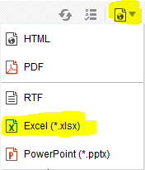

Adding Formulas to Past Year Expenditure Update by Item (Initial Expenditure Report)

The report has 3 sections: GB Public Initials, GB Dept Working, and Changes to Initial. Do the following once you have exported the report to Excel:

- In the second section of the report (GB Dept Working):
- Change title to “Past Year Actuals.”
- Add formulas to all rows in the “Budgetary Expenditure PY” column and in the “Totals” row at the bottom (see salmon colored cells in attachment below). Request Amount + Estimated Savings (negative adjustments in Hyperion) + Carryover (negative adjustments in Hyperion) = Budgetary Expenditures.

- In the third section of the report (Changes to Initial):
- Delete all the data.
- Add Formulas to all columns. The formula within each of the three sections should be Past Year Actuals minus GB Public Initials. For example, the formula for the Incremental Request Amount PY in the Changes to Initial section should equal the Request Amount in the Past Year Actual section minus the Request Amount in the GB Public Initials section (see salmon colored cells in attachment below).

- Add formulas to the Totals row at the bottom of the table to sum data in each column (see salmon colored cells in attachment below).

- Enter data in the Past Year Actual section for Request Amount, Savings, Carryover, and FTE (positions) to match appropriate accounting reports. The Budgetary Expenditures column, all columns in the Changes to Initial section, and the Totals row are formula-driven will automatically populate.

- The formula-driven data in the Changes to Initial section with the exception of Budgetary Expenditures is the data departments should key in or upload into Hyperion. To upload, copy information from that section and paste into upload template (see steps below).

Step1 – Past year report

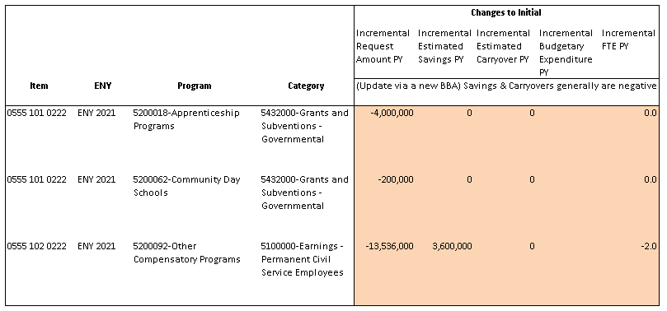

Step 2 – Transfer data into a Past Year BBA upload template

- Expenditures
- Positions
Step 3 – Upload data into Hyperion
NOTE
To verify Hyperion entries tie to the Fund Condition Statement submitted in the package, run the Detailed Multi-Year Report and filter for the specific string and ENY. Review the total in the Budgetary Expenditure PY column to see if the incremental adjustments plus the CSL equals the totals in the backup reports.

How to Run the Revenue Report
- Select the report in the FR report menu:
Explore > select CalPLN23 > select Reports for Departments > select Past Year Incremental RTL Adjustments report (Financial Reporting).

- Select the POV (report parameters):
- Year: “FY23” (because we are building the 2023-24 budget). The report will provide the rolled over past year 2021-22 data.
- Entity: Select your BU.
- Fund: Select the appropriate fund.
- Click OK.
- Version: Pick the following versions:
  - Version 1 (“GB Public Initials”): This version includes rolled over data representing 2021-22 data when the 2022 Budget Act was enacted.
  - Version 2 (“GB Dept Working”): This version includes the same information as GB Public Initials, and will change later as departments enter adjustments throughout the fall process.
- Click OK.

- Export the report to Excel and print, save, or send, as necessary.

Adding Formulas to Past Year Incremental RTL Adjustments (Initial RTL Report)
The report has 3 sections: Revenues PY, Revenue Transfer PY, and Loans PY. Do the following once you have exported the report to Excel:

- In each section, make these changes:
  - Change the title of the middle columns from “GB Dept Working” to “Past Year Actuals” (see yellow cells in attachment below.)
  - Delete all data in the Difference columns.
  - Add formulas to the Difference column for the Revenues PY section only. The formula should be the Past Year Actuals minus GB Public Initials (see blues cells in attachment below).
  - Add formulas to the Total row at the bottom (green cells) to sum all data in each column.
  - Enter data in the Past Year Actual columns to match appropriate accounting reports. The Difference columns are now formula-driven and will automatically populate, as well as the Totals row.
  - Departments will enter their values in the Past Year Actual columns.

- For revenues, the formula-driven data in the Difference column is the data departments should input into Hyperion in a new BR. For Revenue Transfers and Loans, the data in the Past Year Actuals columns is the data departments should input into Hyperion in the existing rolled over BRs.

NOTE
To verify Hyperion entries tie to the Fund Condition Statement submitted in the package, run the RTL by Fund report or the Schedule of RTLs report for a specific fund to verify that totals tie to the backup reports.
For questions, please contact your Finance Budget Analyst.

