Add COVID-19 Custom Attributes to a Project in FI$Cal 2.0
Supplemental Job Aid
Date: 06/11/2020

Revision History
Date | Version | Location | Update Description
06/08/2020 | 1.0 | All Pages | Initial Version
06/11/2020 | 2.0 | Target Audience and screenshots | Edited role and replaced screenshots.

Target Audience: Project Costing Processor (PC Processor).
Purpose: This Supplemental Job Aid provides instructions on establishing COVID-19 related Projects to be used in tracking transactions.

Background: In order to facilitate statewide tracking and reporting of COVID-19 related activities, the Department of Finance (Finance) requires all COVID-19 related transactions (e.g., purchase orders, vouchers, receipts) in FI$Cal to be tagged as COVID-19. In Project Costing, FI$Cal and Finance have established a COVID-19 Custom Project Attribute and three Attribute Values – (1) COVID-19 Response, (2) COVID-19 Testing and Contact Tracing, and (3) COVID-19 Stimulus Programs – for tracking COVID-19 related transactions using the Project ID ChartField. COVID-19 Attribute Values will be chosen from the drop-down function to allow for uniformity across all Business Units (BU’s) to aid in reporting.

Note:
- You must add the COVID-19 Custom Project Attribute and Attribute Values to a Project ID for the Project ID to be tagged as COVID-19.
- You must add a Project ID (tied to COVID-19 Custom Project Attribute and Attribute Values) and Activity ID to a transaction line for the transaction to be tagged as COVID-19.
- COVID-19 Custom Project Attribute and Attribute Values will be associated at the Project header level – this means all transaction lines referencing this Project ID and Activity ID will be tagged as COVID-19.
- Department will continue to create their own Project ID to maintain their internal structure; no smart coding will be required.
- Department will continue to create their own Activity ID(s) to maintain their internal structure; no smart coding will be required.
- This Job Aid does not show steps related to Grant Awards in the Grants Module - Department will continue to create their Grants using their internal process.
- This Job Aid does not show steps related to Customer Contract for billing automation - Department will continue to create their Customer Contracts using their internal process.

- For departments following the COVID-19 “Emergency Attributes” memo from Office of Emergency Services - The COVID-19 Custom Project Attributes are in addition to the COVID-19 Emergency Attributes you were instructed to add to projects via Job Aid FISCal.339. Both the Emergency Attributes and the Custom Project Attributes must be added to your COVID-19 projects.

Examples of Project Attributes Transactions:
COVID-19 Response
Various activities that support the emergency response undertaken by departments in direct response to the pandemic. Activities include, but are not limited to:
- Additional cleaning and sanitation protocols.
- Purchases that support the ability of staff to to telework, or support the implementation of social distancing protocols and public health guidance, such as the purchase of personal protective equipment or partitions and barriers.
- Any activity mission tasked to a department by the Office of Emergency Services (Cal OES). These are also tracked per guidelines from Cal OES and reported to Finance pursuant to BL 20-10 and BL 20-07.
- Redeployment or redirection of staff from regular assignments to COVID-19 response (such as redirection of staff to the State Operations Center or to help support increases in unemployment insurance claims). This would not include staff that are redirected to testing and contact tracing activities identified in the, “Testing and Contact Tracing” section below.
- In most cases, departments have absorbed these costs within existing resources but the state may have an opportunity to submit requests for reimbursement either through the Cal OES/FEMA process, or to allocate costs incurred to the federal Coronavirus Relief Fund. Departments should track and report these costs but may not receive direct reimbursement.
COVID-19 Testing and Contact Tracing
Activities that support statewide testing and contact tracing, as outlined by the California Department of Public Health and the California Health and Human Services Agency. This would include staff that are reassigned to help support this effort.
COVID-19 Stimulus Programs
Many existing programs have been used to rapidly allocate federal stimulus funds. The COVID-19 funds must be tracked separately from the base program funds, even if the Catalog of Federal Domestic Assistance (CFDA) is the same for both. In addition to tracking them separately, it is important to note that COVID-19 allocations may also have unique requirements relative to allowable uses (including flexibility), matching, reporting, or period of availability, which must be carefully tracked or monitored. The majority of the funding being allocated to or through the state, as reported pursuant to the federal tracking drill, will fall into this category.

Track COVID-19 related transactions using Federal Grant (new or existing) and State Funded (new)

Step 1: Establish a new project for tracking transactions. Navigate to the General Information page to add a new project:
- Navigation: Main Menu Project Costing Project Definitions General Information

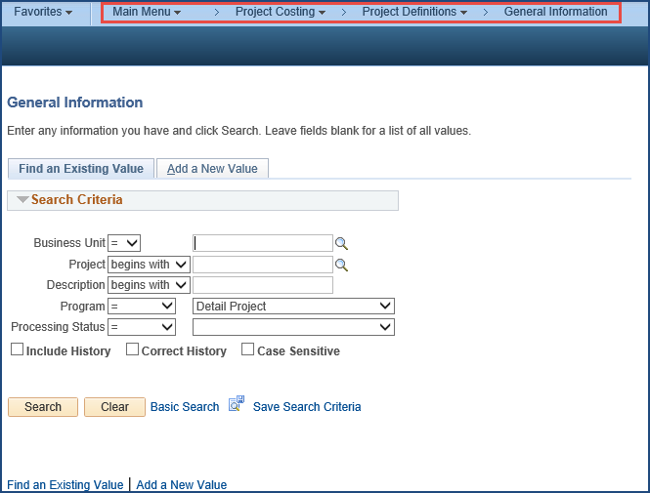

Step 2: Click the Add a New Value tab

A new Project is created by clicking the Add a New Value tab and entering the following:
- Business Unit
- Project: System will generate the next available Project number if using the “NEXT” functionality. If not using the “NEXT” functionality, enter the Project number manually.

Then click the Add button.
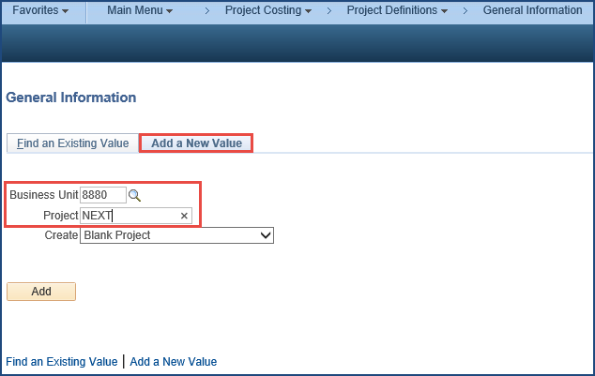

Step 3: On the General Information tab, enter or select values for the following:
- Description: <Enter project description> This is a 30 character field
- Integration: <Department Business Unit>
- Project Type: <Select a Value> Use the appropriate Project Type based on the project being created
- Start Date: <User Defined> Establish start date based on when activity was authorized
- End Date: <User Defined>
- Description: Enter detailed description (optional) under Project Schedule section

Click Save.

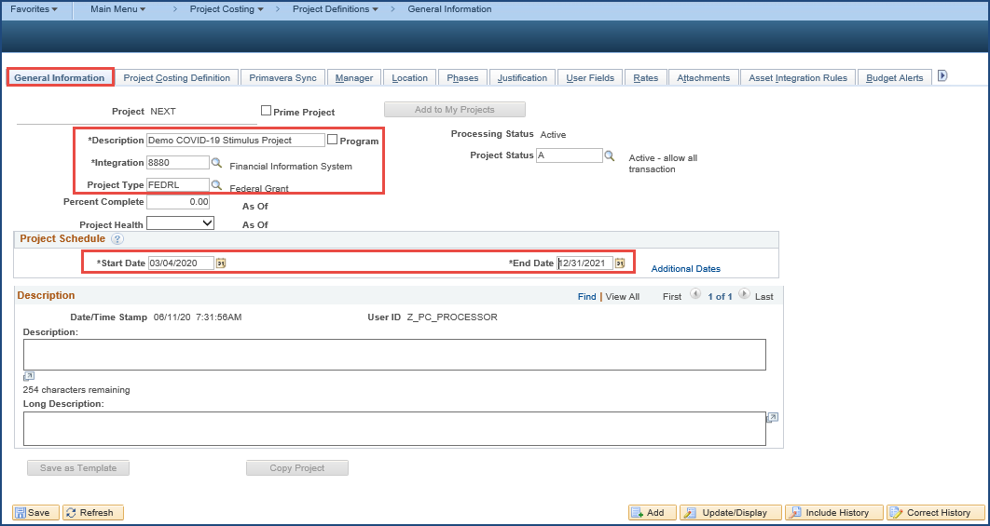

Step 4: (Federal Projects Only – Project Type FEDRL): Federal Projects will be sent to the User Fields tab, click OK to message. Enter CFDA Number, P/N and C then click on Save (system will generate Project ID, if NEXT was used).
Note: If you received a new CFDA grant, please ensure you have the Sequential Number and Character number from SCO – the System will not allow blanks in these fields.
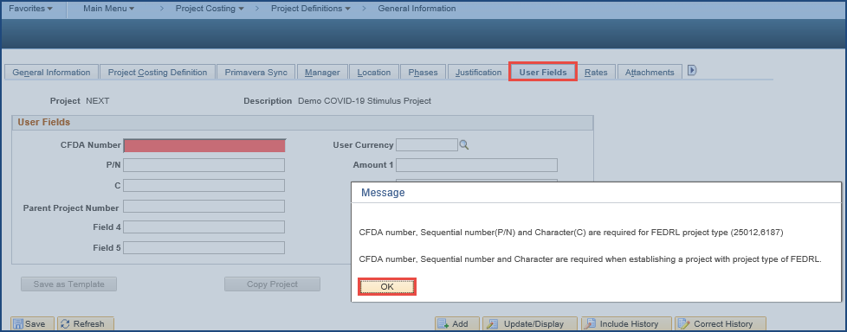
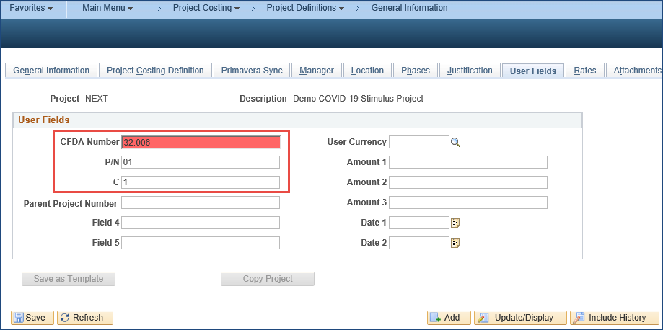

Step 5: Create Activity ID(s) for Project. Click on the “Project Activities” hyperlink at the bottom of the page:
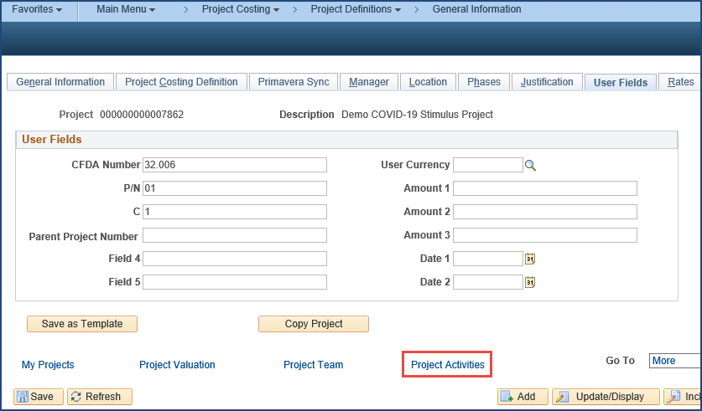

Step 6: On the Project Activities page under the Schedule tab, enter Activity Name then click the Save button. Can also replace the “NEXT” in Activity field if a certain value is required to maintain an internal structure and detail tracking. Then click the Activity Definition icon (on righthand side next to the “Percent Completed” field) to activate the status of the project activity. This will open General Information page.
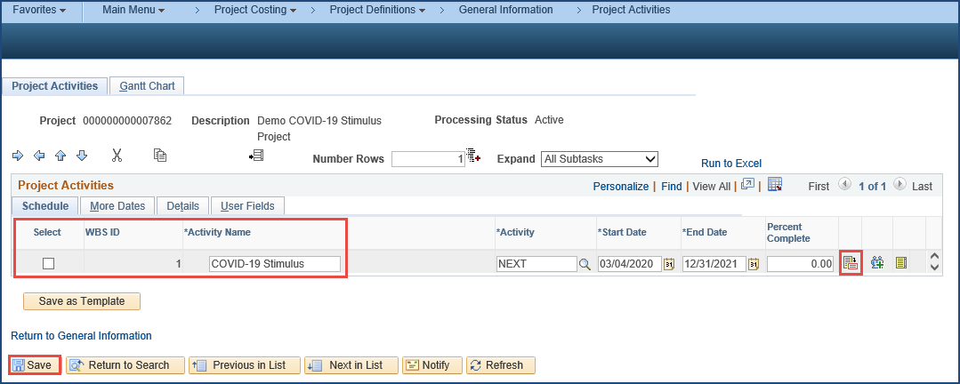

Step 7: On the bottom of the General Information page, click the Activity Status hyperlink.
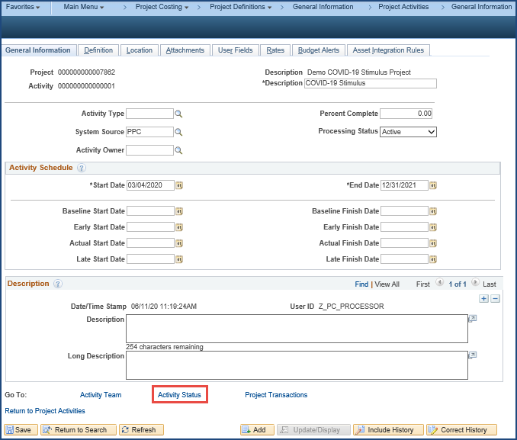

Step 8: On the Status page, set Effective Date to be the same as the Project start date, select “A” (for Active) from the Status prompt, then click the Save button.
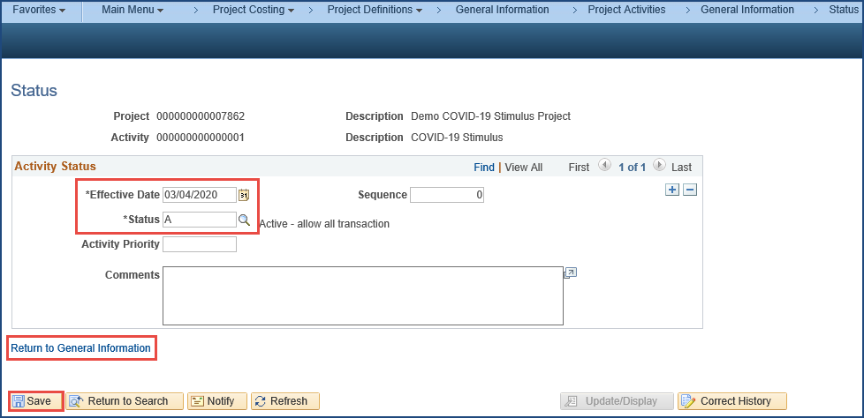

Then click on the “Return to General Information” hyperlink to go back to General Information page as shown on Step 7.
Then click on the “Return to Project Activities” hyperlink to go back to Project Activities page as shown on Step 6.
Then click on the “Return to General Information” hyperlink.

Step 9: Navigate to the Project Attributes tab (by scrolling to the right).
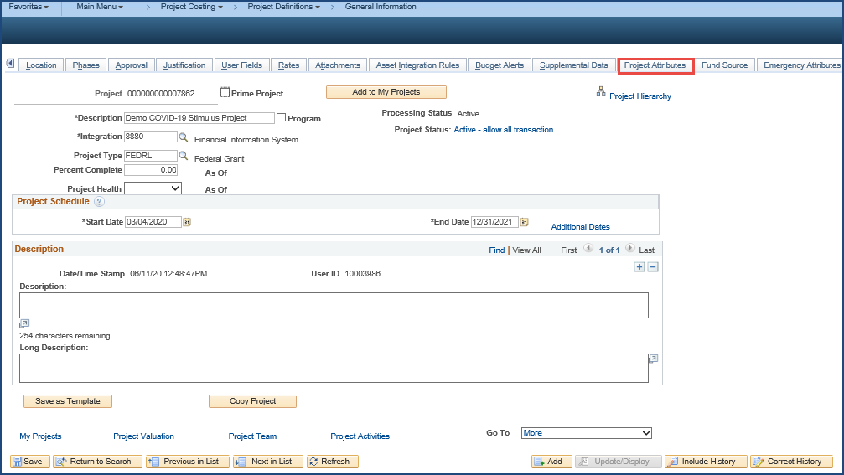
Step 10: Click the Project Attributes tab and in the Custom Attributes section, enter the following values:
- Attribute Name: click Lookup, select “COVID-19”
- Value Drop Down: <select from dropdown>
  - “Response” – for tracking expenditures directly related to COVID-19 response
  - “Testing and Contact Tracing” – for tracking expenditures directly related to COVID-19 testing and contact tracing
  - “Stimulus Programs” – for tracking expenditures directly related to COVID-19 stimulus programs

Then click Save.
Note: A project should only have one project attribute with “COVID-19” and a single attribute value. Also, the project should only be used to track COVID-19 costs of the specified type (“Response”, “Testing and Contact Tracing”, or “Stimulus Programs”). If the BU has COVID-19 activities of multiple types, multiple COVID-19 projects should be created. Any non-COVID-19 expenditures should be tracked with a different project.
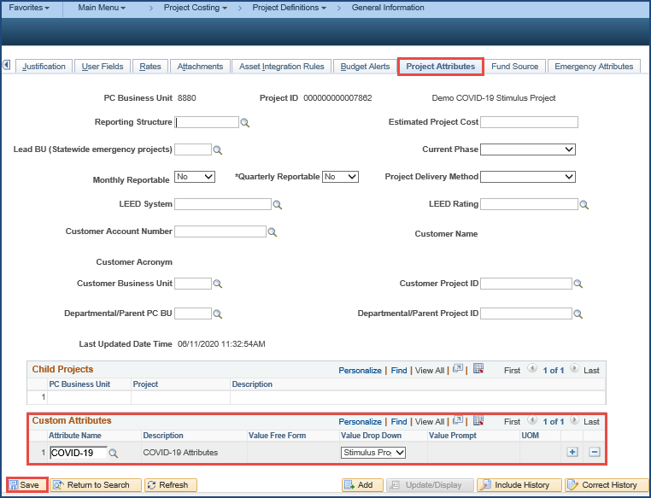
Step 11: (Federal Projects Only – Project Type FEDRL) Create a Configuration Modification Request (CMR) via ServiceNow – instructions located here: Create a Configuration Modification Request – to add the new Project(s) to the FTF Tree under the appropriate CFDA number.
You have now successfully created the Project and Activity related to COVID-19 to be used on transactions in other modules (like Purchase Orders, Vouchers, Accounts Receivable, General Ledger, etc.). All transactions related to COVID-19 must be associated with a COVID-19 Project to facilitate statewide tracking and reporting.
Step 12: Enter Project ID and Activity ID on all transactions related to COVID-19.
Note: You must add a Project ID (tied to COVID-19 Custom Project Attribute and Attribute Values) and Activity ID to a transaction line for the transaction to be tagged as COVID-19. COVID-19 Custom Project Attribute and Attribute Values will be associated at the Project header level – this means all transaction lines referencing this Project ID and Activity ID will be tagged as COVID-19.
PO Distribution Line Entry

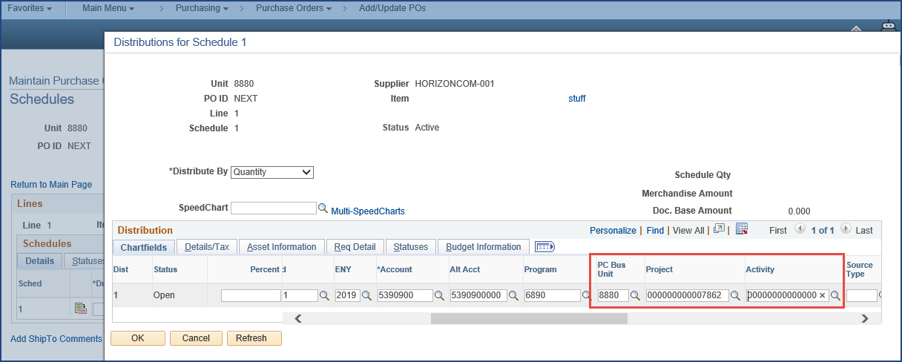

Voucher Distribution Line Entry

